**GYM APPLICATION**

**by THE A TEAM**

Contents

**I.** **Requirements** 3

**II.** **Application** 4

II.1. Authentication 4

II.2. Navigation menus 5

*II.2.1. Logged-out user menu* 5

*II.2.2. Administration menu* 6

*II.2.3. Trainer menu* 8

*II.2.4. Client menu* 8

II.3. Application Management 9

*II.3.1. User Management\** 9

*II.3.2 Workout Management\** 13

*II.3.3. Subscription Management* 16

*II.3.4 Room Management* 20

*II.3.5. Timetable Management\** 22

*II.3.6. Promotion Mails Management* 25

II.4. Client Overview 27

*II.4.1. Home* 27

*II.4.2. Trainers* 28

*II.4.3. Subscription* 29

*II.4.4. Schedule* 29

*II.4.5. Contact* 30

**\***also applied to users logged-in as trainers.

# **Requirements**

A gym owner has requested that we build a web application, which will handle the following:

1. Management of trainers, subscriptions and available rooms by an administrator
2. Management of classes by an administrator or a trainer
3. Client registration by a trainer
4. Adding and extending client subscriptions by a trainer
5. Managing users to classes by a trainer

The gym owner has also expressed the desire to extend that web application in two additional steps. The first step will include:

1. An extension of the web application on the client side, which will contain: a) a home page b) info pages about the trainers c) info pages about the subscriptions d) a schedule page e) a contact page with the location of the gym placed in a Google Maps container f) a client login page
2. The info pages will contain an image, a description, the price if it's a subscription page, and a feedback mechanism based on stars (1 being the worse and 5 the best). Only logged in clients can give feedbacks.
3. The schedule page displays the schedule for a specific week. It has a tabular form and it must respect the following colouring principles: - light grey for classes that are already in the past - green for classes of easy intensity - orange for classes of medium intensity - red for classes of high intensity The name of the class and the trainer should also be visible in each tab.
4. According the user the possibility to manage himself the classes he/she wants to attend to

The second step will include:

1. Extending the web application on the administration side, which will contain: a) one extra page where administrators can send periodic mails to clients, containing important informations, discounts, new classes, etc. The new page must contain:

* a Subject input
* a Body input
* a subscription list

Mails shall be then sent to all the clients which will have active subscription(s) found under the selected subscription(s).

# **Application**

## **II.1. Authentication**

In order to use GymApp you have to log yourself in by using the “Log in” button, which is located in the right top corner of the home page.

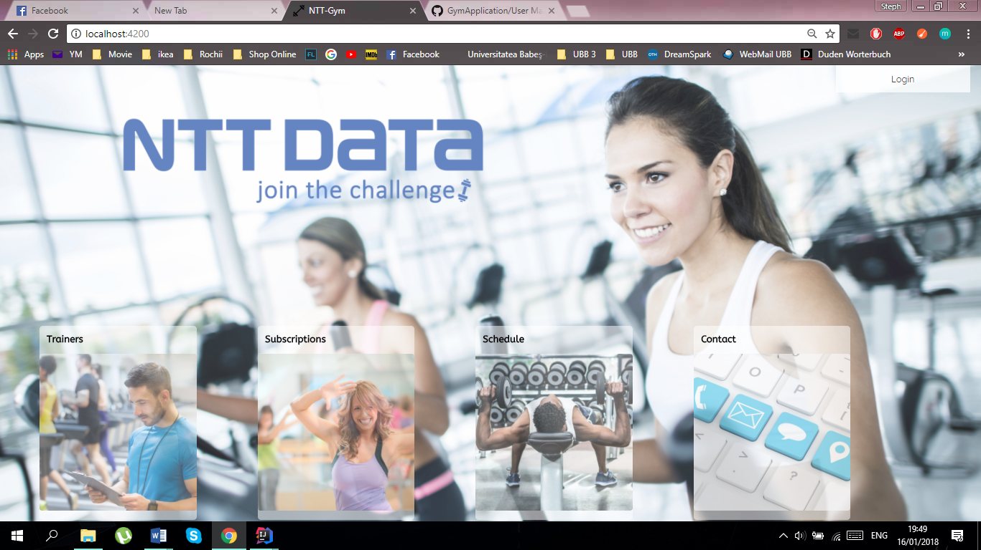

*Fig.* ***1.*** *Home Page*

You will need your username and password (admin, trainer). If you are a client, your password is your CNP.

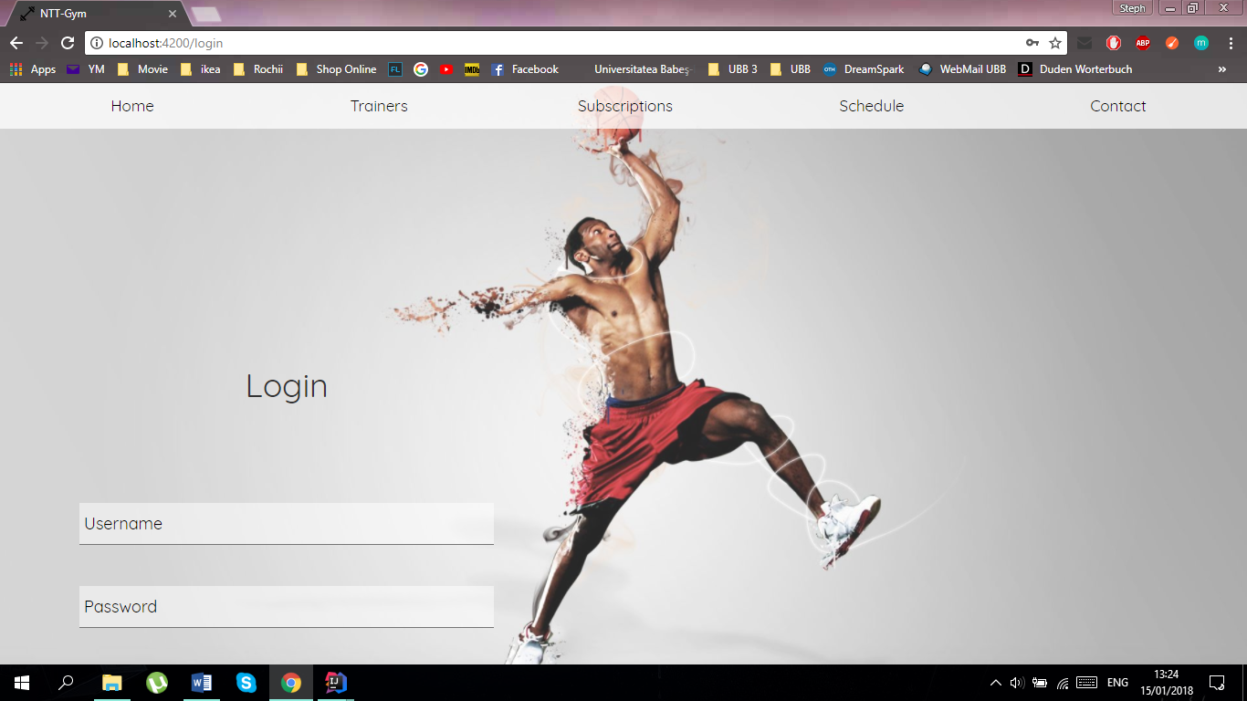

*Fig.* ***2.*** *Login Page*

For logging out you can use the button, which is located on the top of the page in the right corner.

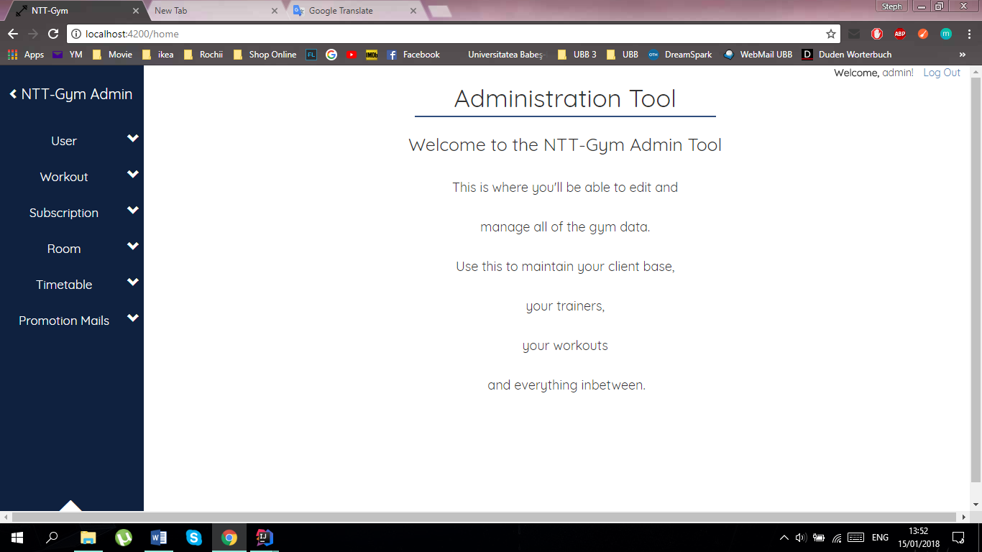

*Fig.* ***3.*** *Log out button*

## **II.2. Navigation menus**

### *II.2.1. Logged-out user menu*

Users who don’t have an account, can easily enter GymApp. The menu below will be available for them.

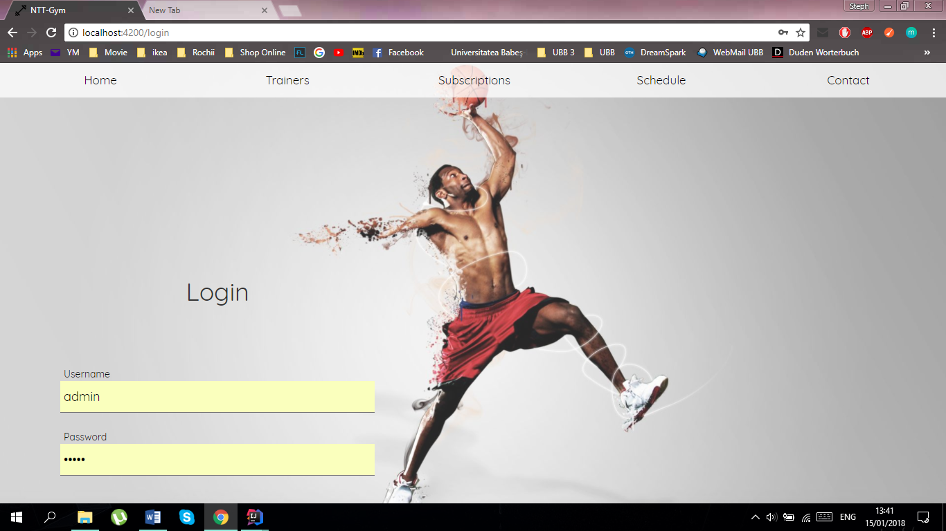

*Fig.* ***4.*** *Logged out user menu*

The Home button will take you to the home page, where you can access the following categories:

* Trainers
* Subscriptions
* Schedule
* Contact

These are also reachable from the Log-In page.



*Fig.* ***5.*** *Home Page*

### *II.2.2. Administration menu*

If you are logged in as an admin (default username and password are both “admin”) then you will be able to see the following menu only seen by a user with the admin type.

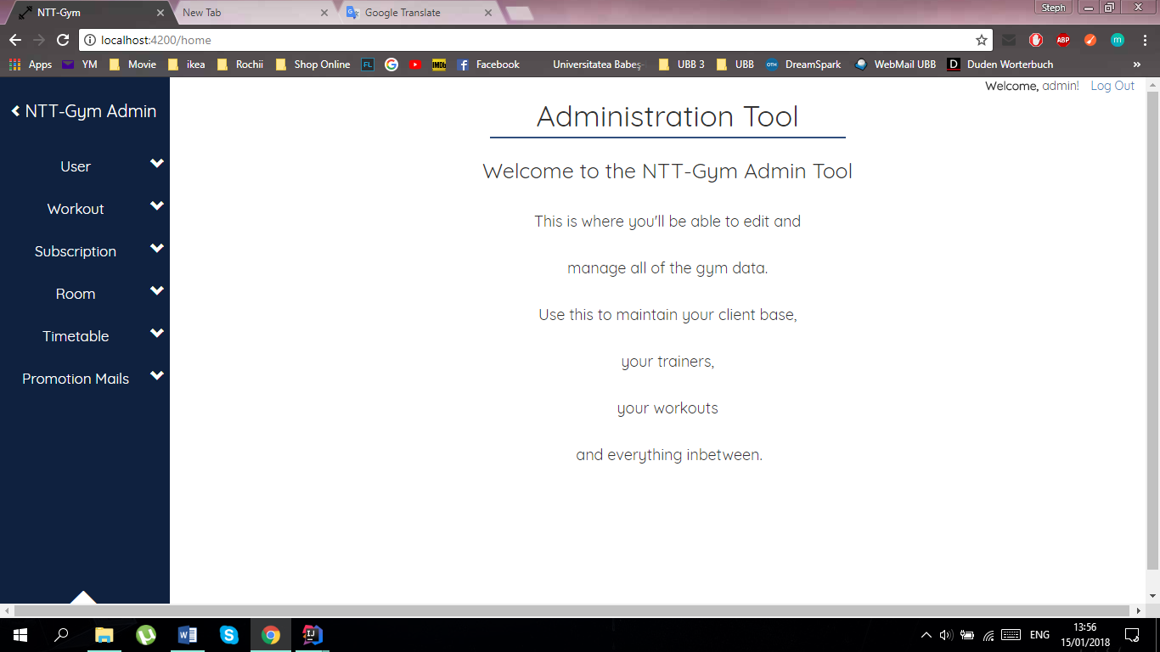

*Fig.* ***6.*** *Navigation menu*

On the left side of the application, you can always find the navigation pane.

In order to view the subitems of a specific item, click on the desired item, like the one marked with red in the picture.

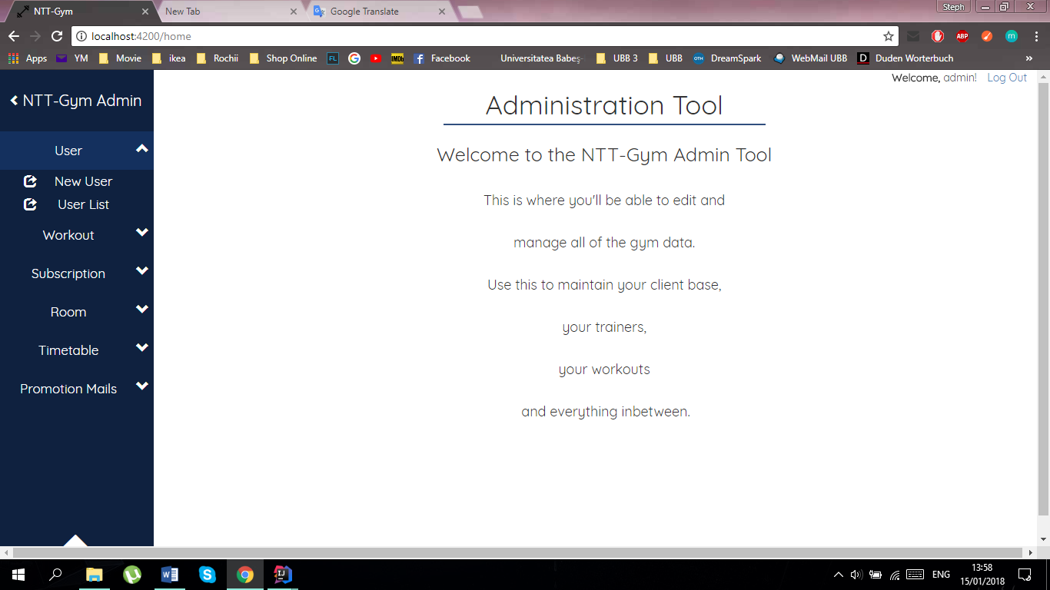

*Fig.**7****.*** *Navigation menu*

What you will then see are the subitems of the selected item. You can now navigate to different pages regarding the item, like creating a new entry or seeing all entries of that type.

Click on one of the subitems, like the one marked in red, to navigate to the corresponding page. Then, you will be presented with the selected page.



*Fig.* ***8.*** *Navigation menu subitems - User*

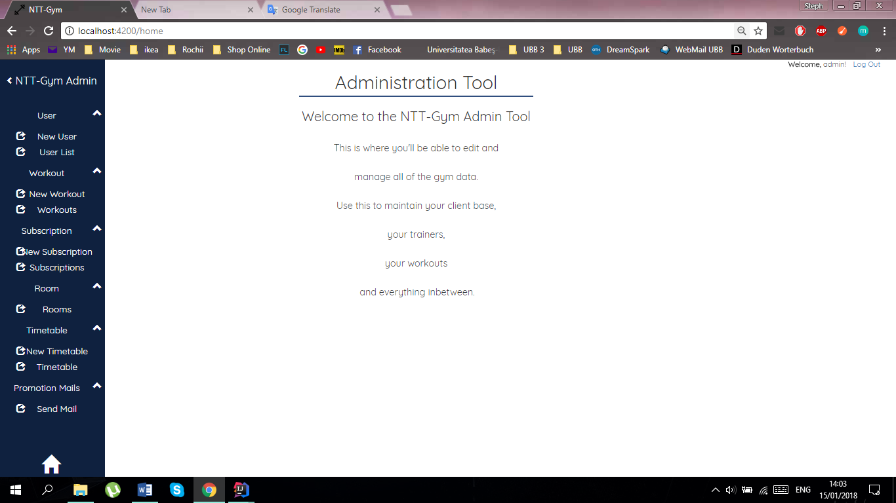

These are all the options you can choose at the moment.

You can have all navigation items expanded at the same time.

If you want to collapse the items again, just click on one of them.

*Fig.* ***9.*** *Navigation menu subitems - All*

### *II.2.3. Trainer menu*

If you are logged in as a trainer you will be able to see the following menu.

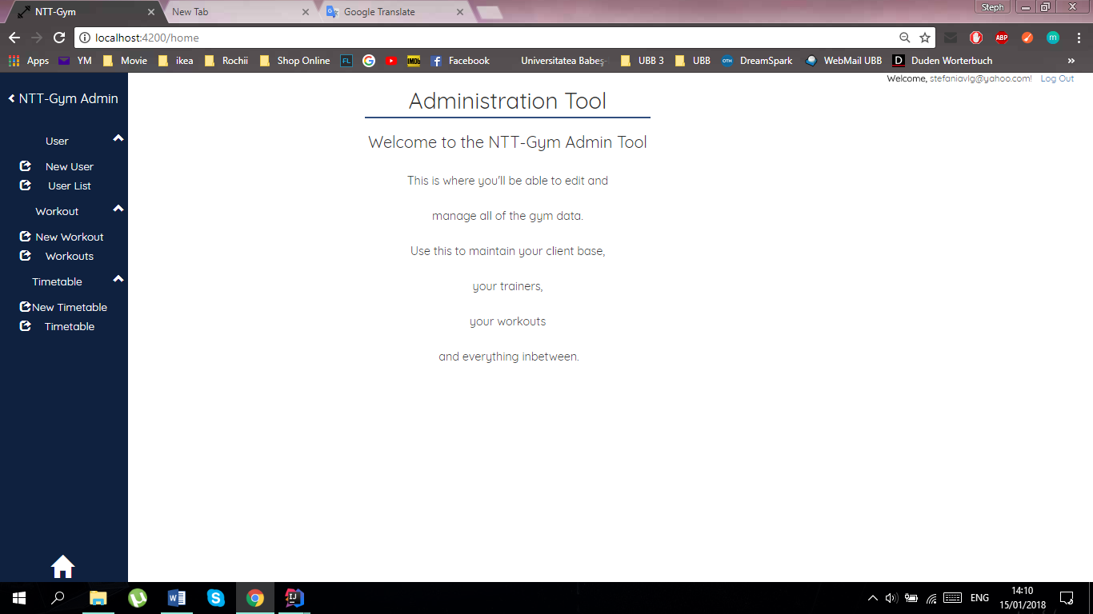

*Fig.* ***10.*** *Navigation menu Trainer*

### *II.2.4. Client menu*

As a client you have access to the following menu. You can see the list of trainers, subscriptions and the schedule of our daily workouts.



*Fig.* ***11.*** *Navigation menu Client*

## **II.3. Application Management**

### *II.3.1. User Management\**

In this part you will be given information about the management of users of the gym application. The following functionalities will be included:

* Create New User
* User List
* Update User
* Delete User.

In order to access the user management pages, the user has to be authenticated, and have administrative or trainer rights. You can access these functionalities by selecting the „User” option from the menu. Selecting „User” from the menu will allow you to access the next two options: New User and Users.

#### II.3.1.1. User creation

If you want to create a new user you will have to follow the next steps.

1. Click on “New User” (this will take you to another page).

2. Write in the user's data.

3. Choose the user’s type (Trainer, Client, Admin). Be careful when choosing the type! The account (with almost all functionalities) will be different for each type of user.

4. Click on the button "Submit".

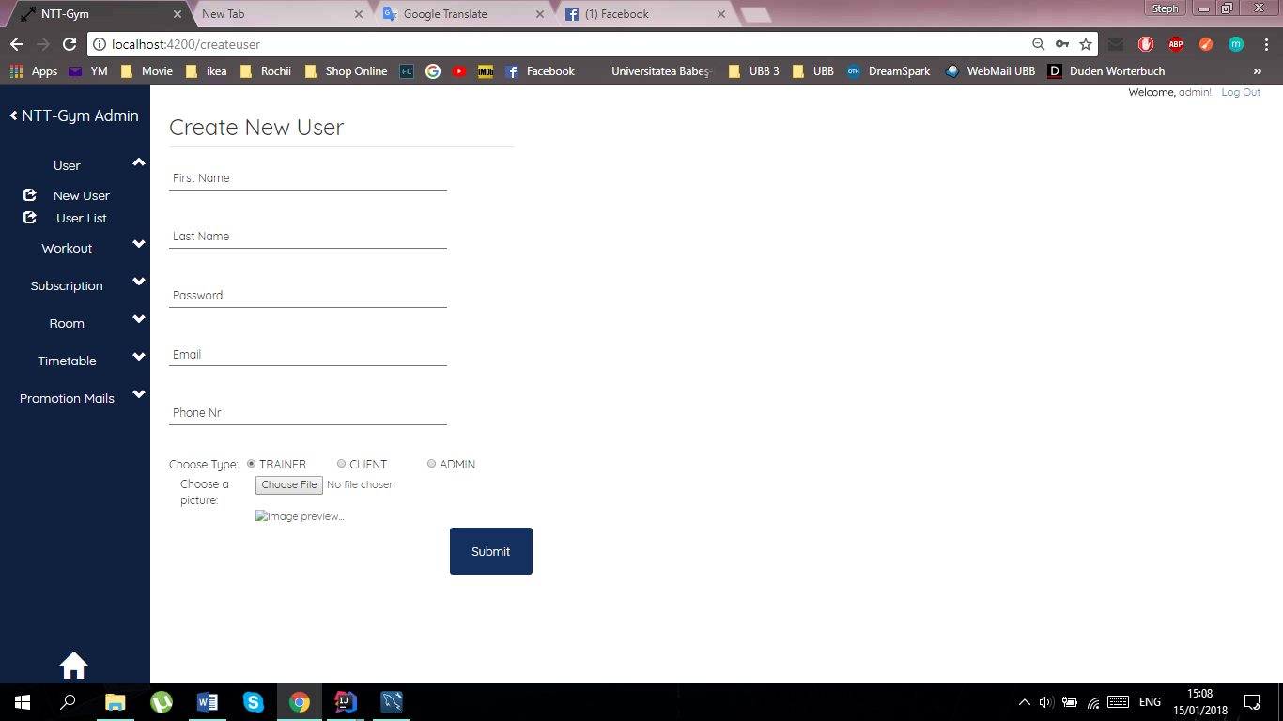

*Fig.* ***12.*** *Create User Page*

If the user was created successfully then you will receive a confirmation message at the top of the page.

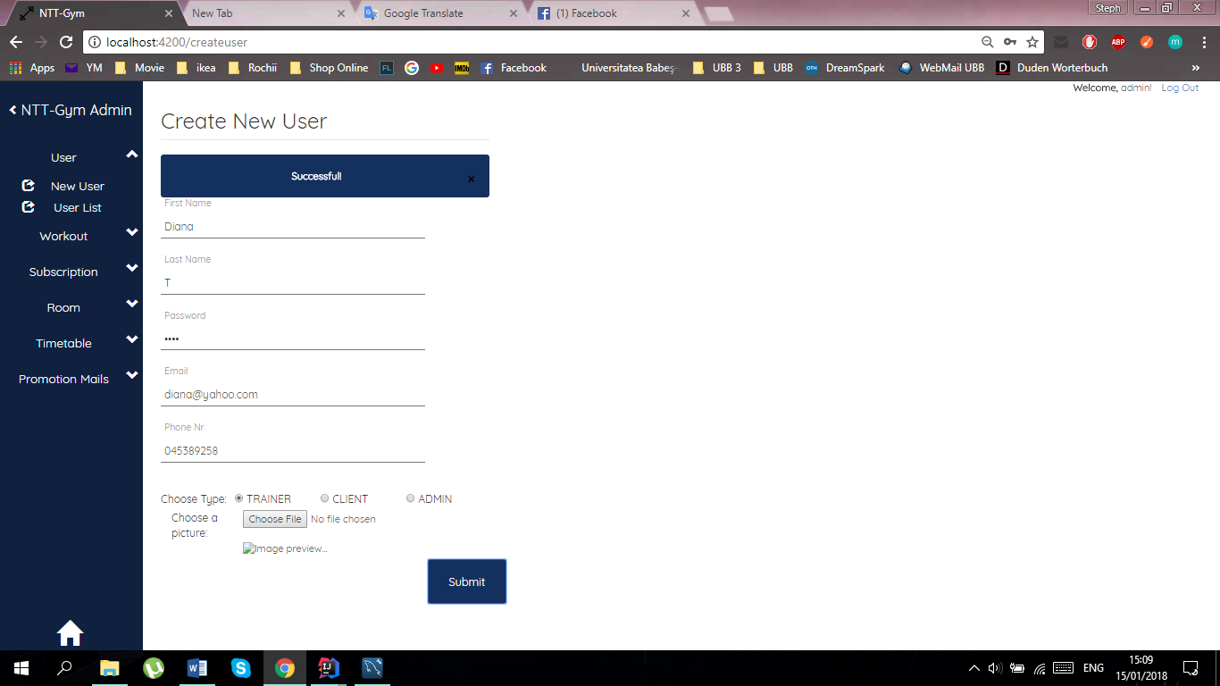

*Fig.* ***13.*** *Success message*

#### II.3.1.2. User List

Once you clicked on “User List”, the application will show you the list of users that are currently using GymApp. Information about these users are also shown. If a user has the type as client then the column “Start” and “Subscription” won’t be empty.

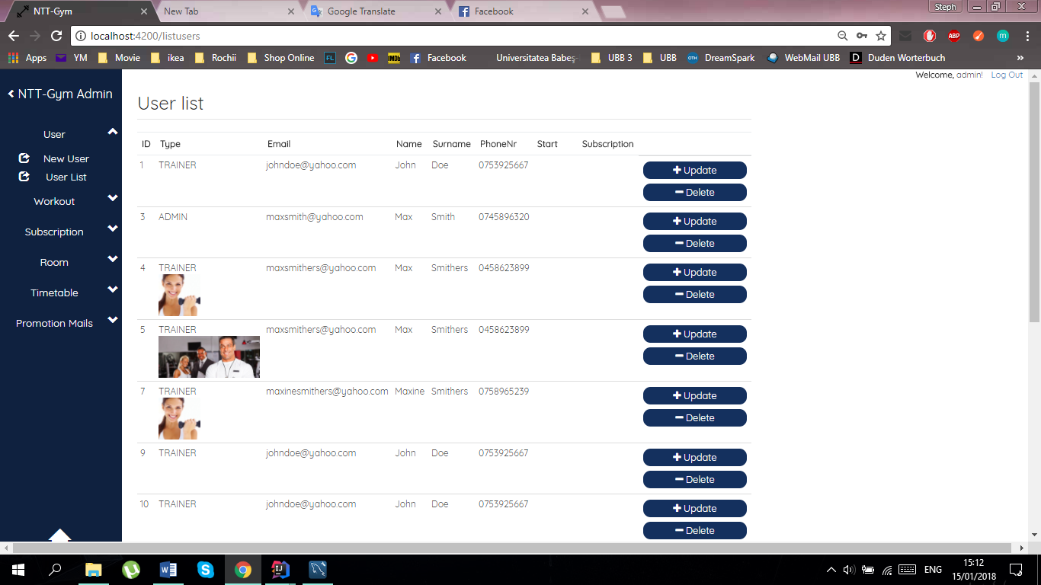

*Fig.* ***14.*** *User List Page*

#### II.3.1.3. User Update

If some information about a specific user needs to be changed, then this can be easily done with the help of the button “Update”, which is located on the right side of the (User List) page, next to the user’s information.

On the Update User page you can update the information for a certain user. After finishing with the updates for a specific user, the changes will be updated after one click on the “Submit” button. A message will appear if the update was done successfully.

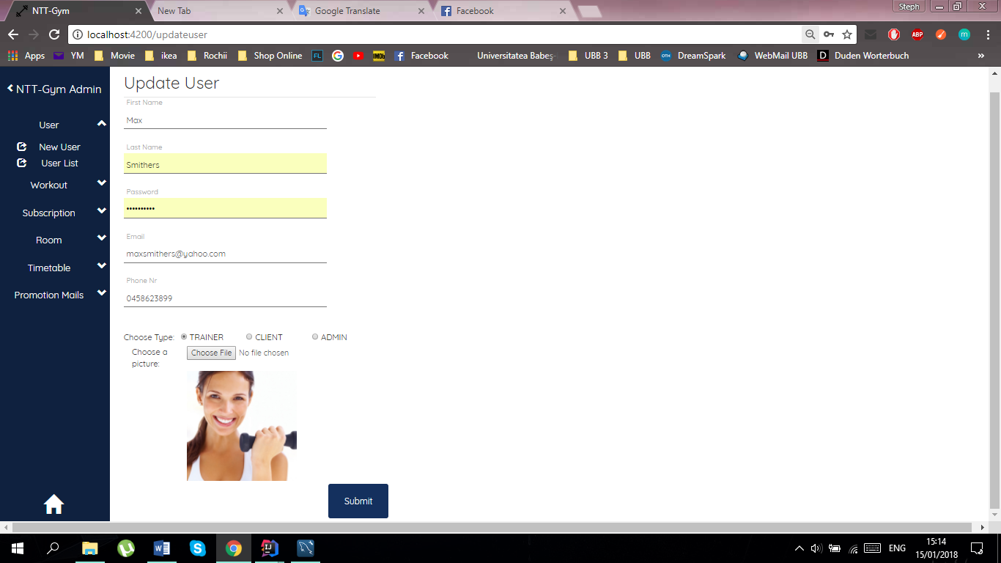

*Fig.* ***15.*** *Update User Page*

For users, who are clients, you can update their subscriptions as seen in the picture below.

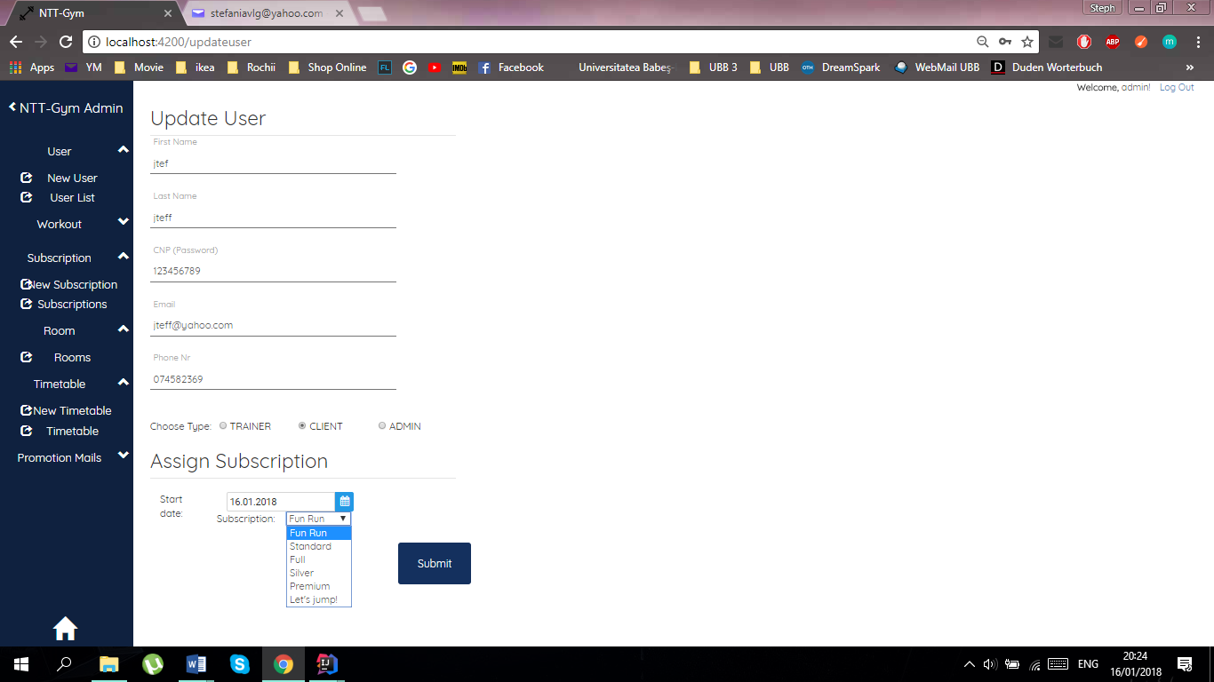

*Fig.* ***16.*** *Update User Page*

You can change the start date and choose another subscription from the given dropdown list.

#### II.3.1.4. User Deletion

When a particular user needs to be deleted, this can simply be done by using the “Delete” button, which is located on the right of the (User List) page, below the “Update” button. One click on the button will delete the user that is no longer needed and a confirmation message will be shown.

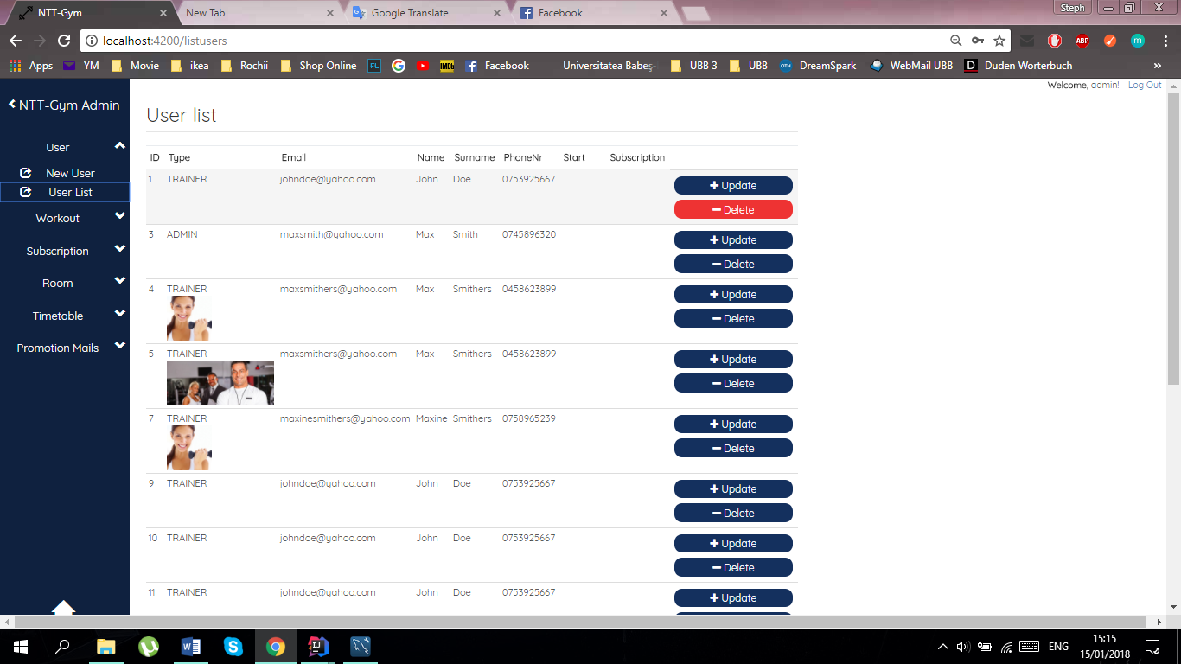

*Fig.* ***17.*** *User List Page – Delete*

#### II.3.1.5. User Schedule

For users who are clients, you can update their schedule. This can be done by using the “Edit Timetable” button, which can only be seen at client users.

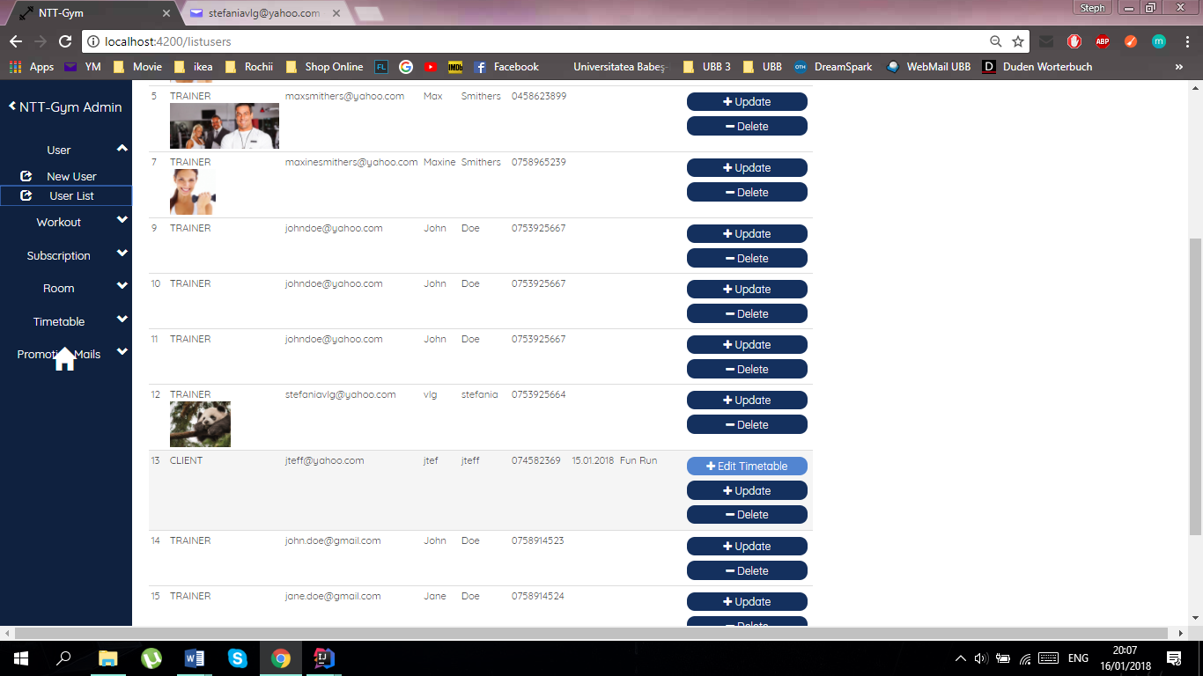

*Fig.* ***18.*** *Client Edit Timetable*

This will lead you to the page seen below. The client’s schedule is created by adding new classes. If a client wants to take a new class, you can select the date when the client has the class from a calendar and you can see all the workouts of that day. If there is one class in that day, it will be automatically placed, and if there are more available, you can choose one. Once you have finished, click on the submit button and the class will be added in the list of the schedule. If you want to delete a class from the schedule, you can simply click on the “Delete” button, located on the right, next to each class.

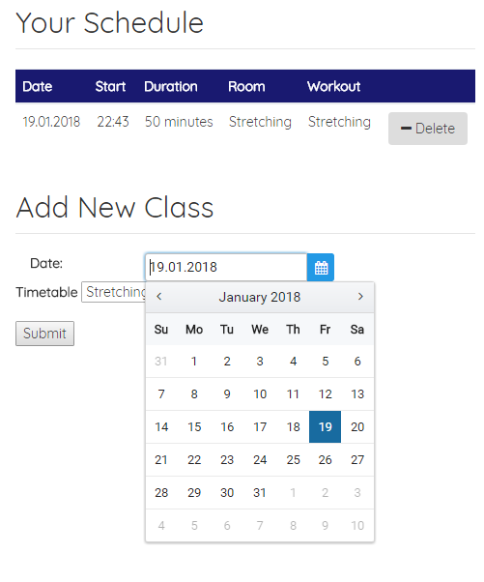

*Fig.* ***19.*** *Edit Timetable page*

### *II.3.2 Workout Management\**

In this part you will be given information about the management of workouts of the gym application. The following functionalities will be included:

* Create New Workout
* Workout List
* Update Workout
* Delete Workout.

In order to access the workout management pages, the user has to be authenticated, and have administrative rights. You can access these functionalities by selecting the „Workout” option from the menu. Selecting „Workout” from the menu will allow you to access the next two options: New Workout and Workouts.

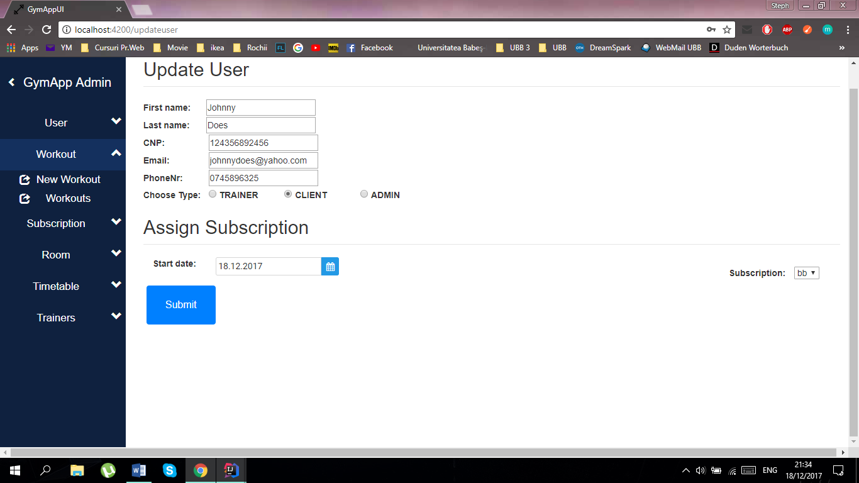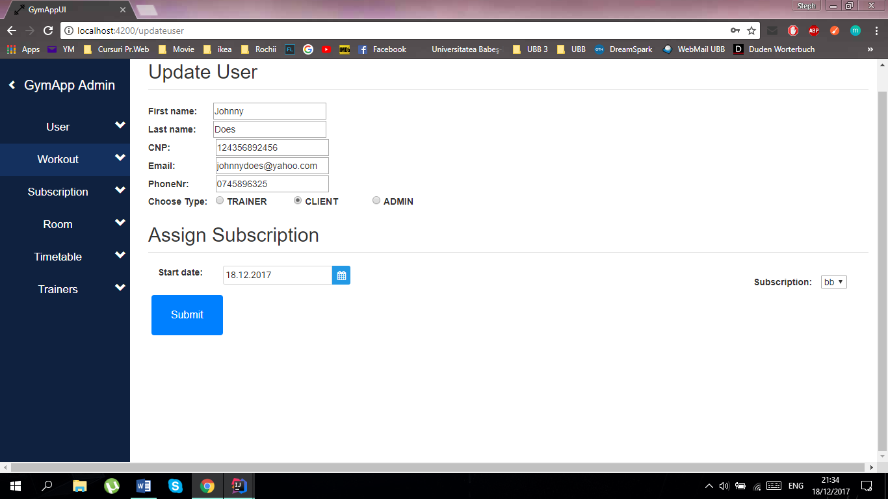

*Fig.* ***20.*** *Workout Menu*

#### II.3.2.1. Workout creation

In order to create a new workout please select the option „New Workout” from the submenu. Accessing this option will display the following page:

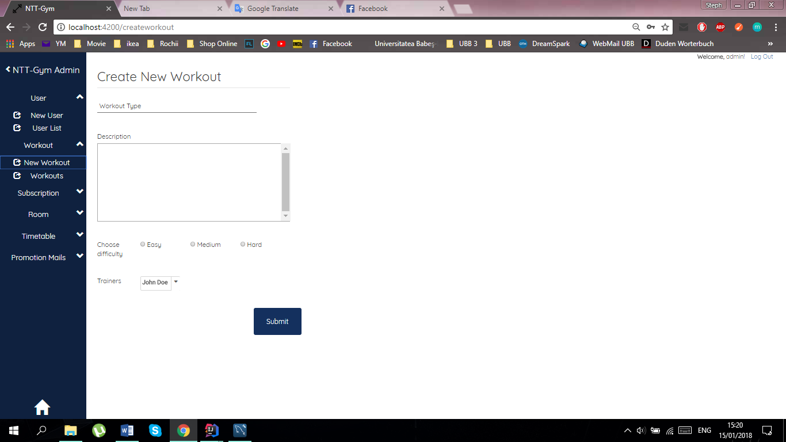

*Fig.* ***21.*** *Create Workout Page*

To create a new workout please complete the fields *1 and *2, select the difficulty *3 and choose a trainer from the list of trainers 4*. To complete the operation click the „Submit” button. A message will appear if the workout was added successfully.

#### II.3.2.2. Workout list

The list of workouts can be viewed from the menu by selecting "Workouts". This option allows you to view and manage the workouts of the gym. Accessing this option will display the following page:

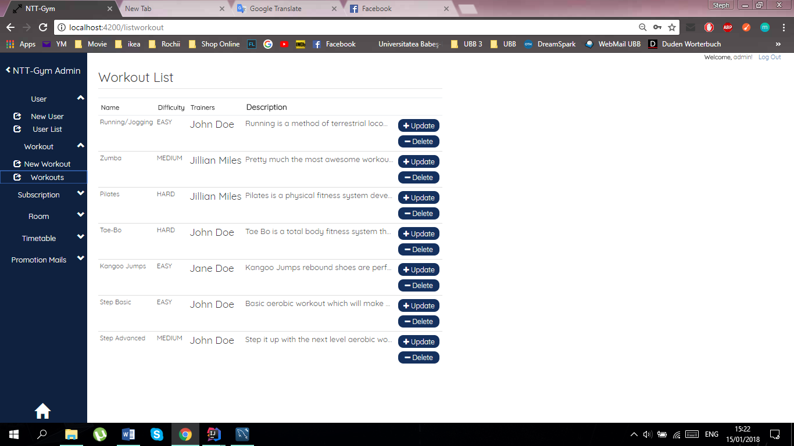

The „Delete” button allows you to delete a specific workout.

*Fig.* ***22.*** *Workout List Page*

#### II.3.2.3. Workout Update

If some information about a specific workout needs to be changed, then this can be easily done with the help of the button “Update”, which is located on the right side of the (Workout List) page. By clicking this button, you will be redirected to a new page where you can choose the fields to be modified.

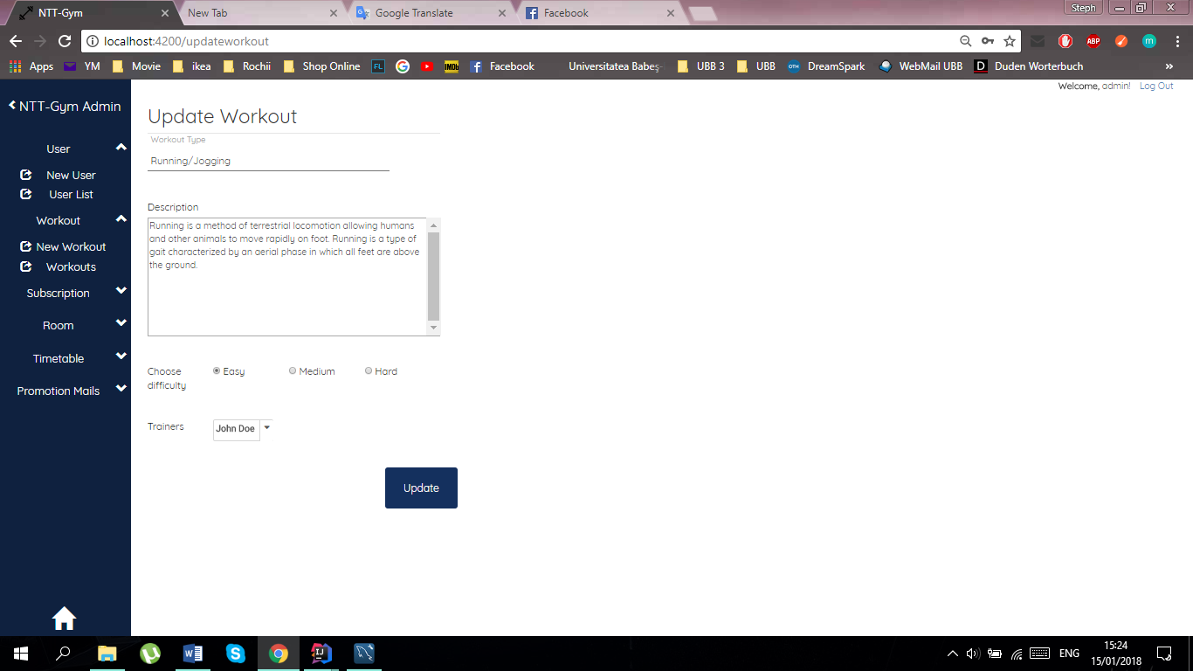

*Fig.* ***23.*** *Workout Update Page*

To update a specific workout enter new values in the fields *1 and *2, select a new difficulty *3 and choose new trainers from the list of trainers 4*. In order to complete the operation click the „Update” button. A message will appear if the update was done successfully.

#### II.3.2.4. Workout Deletion

When a particular workout needs to be deleted, this can simply be done by using the “Delete” button, which is located on the right of the (Workout List) page, below the “Update” button. One click on the button will delete the workout that is no longer needed and a confirmation message will be shown.

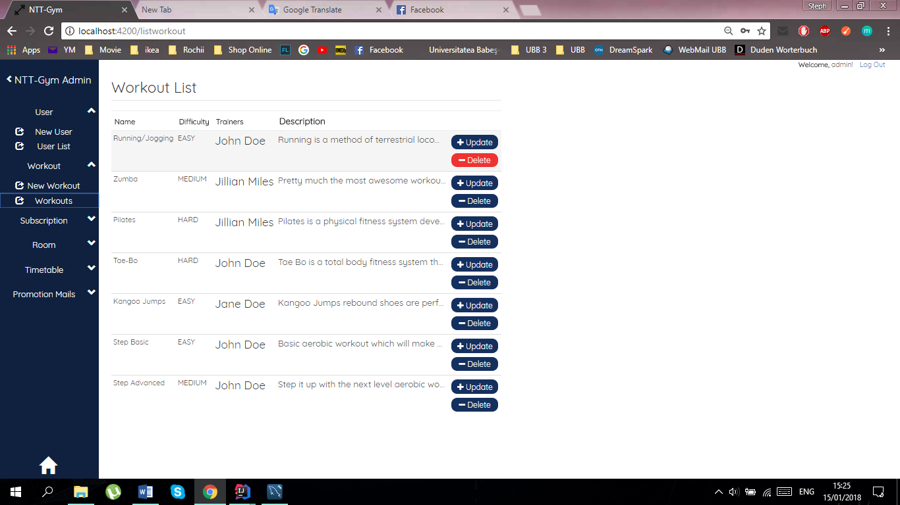

*Fig.* ***24.*** *Workout List Page*

### *II.3.3. Subscription Management*

In this part you will be given information about the management of subscriptions of the gym application. The following functionalities will be included:

* Create New Subscription
* Subscription List
* Update Subscription
* Delete Subscription.

In order to access the subscription management pages, the user has to be authenticated, and have administrative rights. You can access these functionalities by clicking on “Subscription” in the main menu, a drop down menu will open which will give you two choices: “New Subscription” and “Subscriptions”.

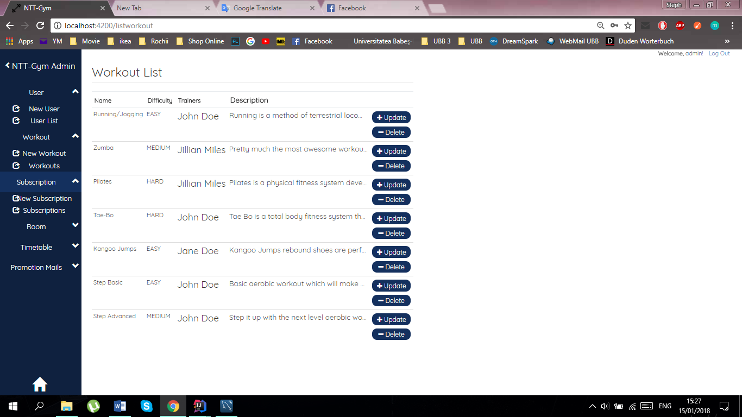

*Fig.* ***25.*** *Subscription Menu*

#### II.3.3.1. Subscription creation

The “New Subscription” option gives you the choice to create a new custom subscription, where you can set a name, price, duration and select the desired workouts from a drop down.

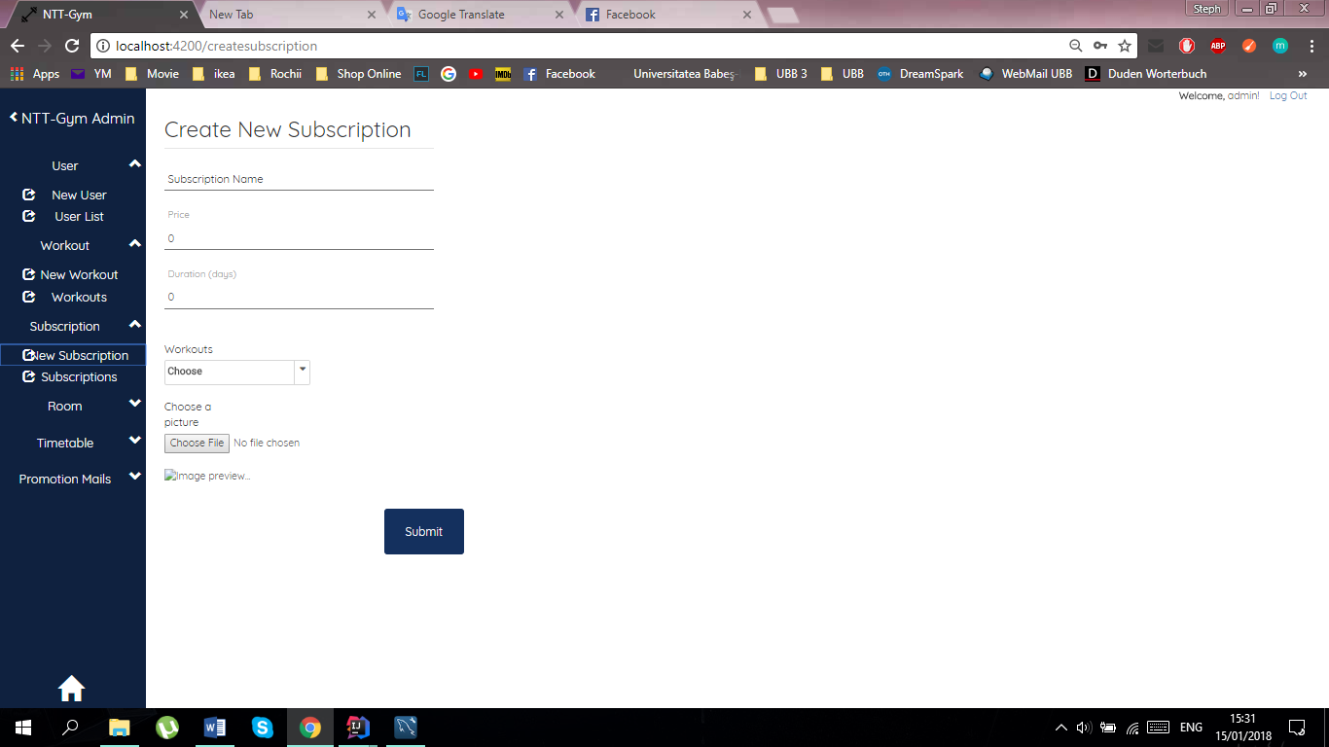

*Fig.* ***26.*** *Create Subscription and available Workouts*

Click the “Add” button after completing all the fields. If the creation is completed, a new subscription will be added to the data base and you will see a “Successful” message.

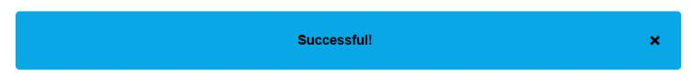Close the pop-up by pressing the x button on the right-hand side.

#### II.3.3.2. Subscription List

The list of subscriptions can be viewed from the menu by selecting "Subscriptions". This option allows you to view and manage the subscriptions of the gym. Accessing this option will display the following page:

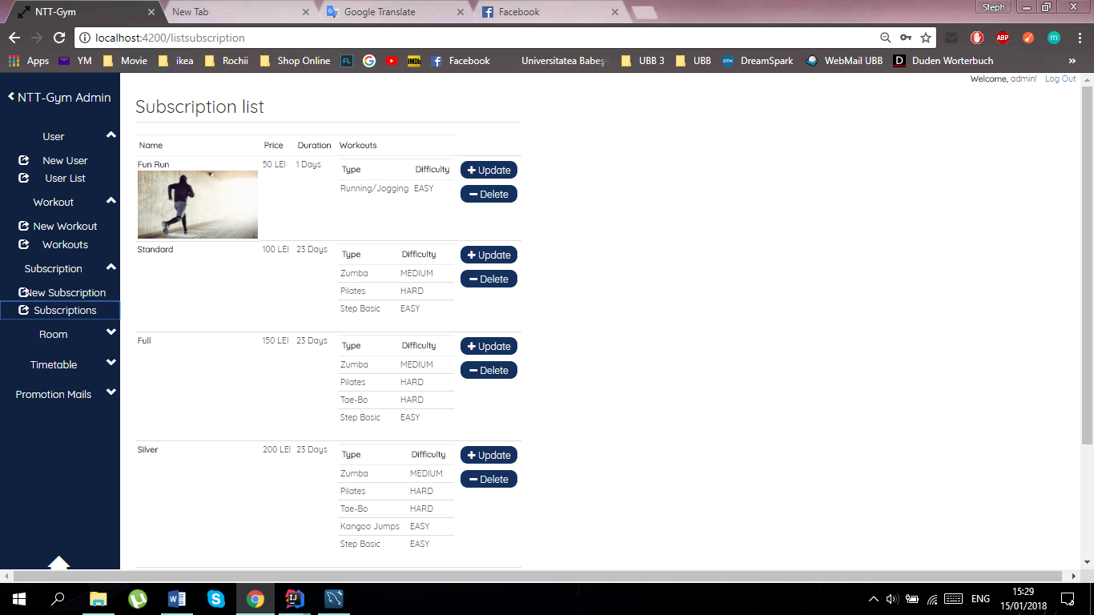

*Fig.* ***27.*** *Subscription List Page*

The Subscriptions list displays all the possible subscription types together with their details. The user has the possibility to Delete or Update a subscription.

#### II.3.3.3. Subscription Update

By clicking on one of the “Update” buttons in the subscription lists, you will be redirected to the Update Subscription page. Here you can modify all the details of a subscription (name, price, duration and the type-list by selecting multiple workouts).

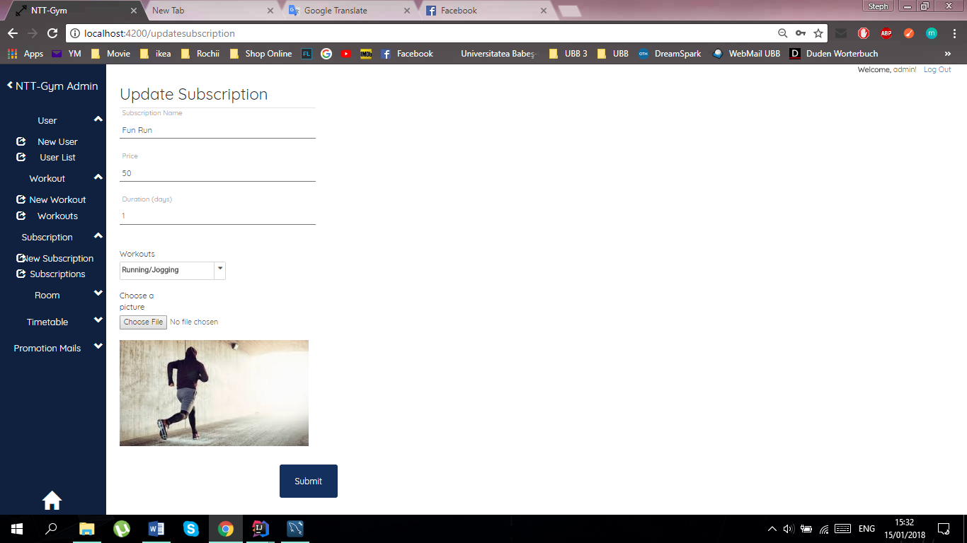

*Fig.* ***28.*** *Update Subscription Page*

Press the “Submit” button in the bottom right-hand corner after completing all the fields. When the subscription is up to date you will see the “Successful” pop-up.

#### II.3.3.4. Subscription Deletion

When a particular subscription needs to be deleted, this can simply be done by using the “Delete” button, which is located on the right of the (Subscription List) page, below the “Update” button. One click on the button will delete the subscription that is no longer needed and a confirmation message will be shown.

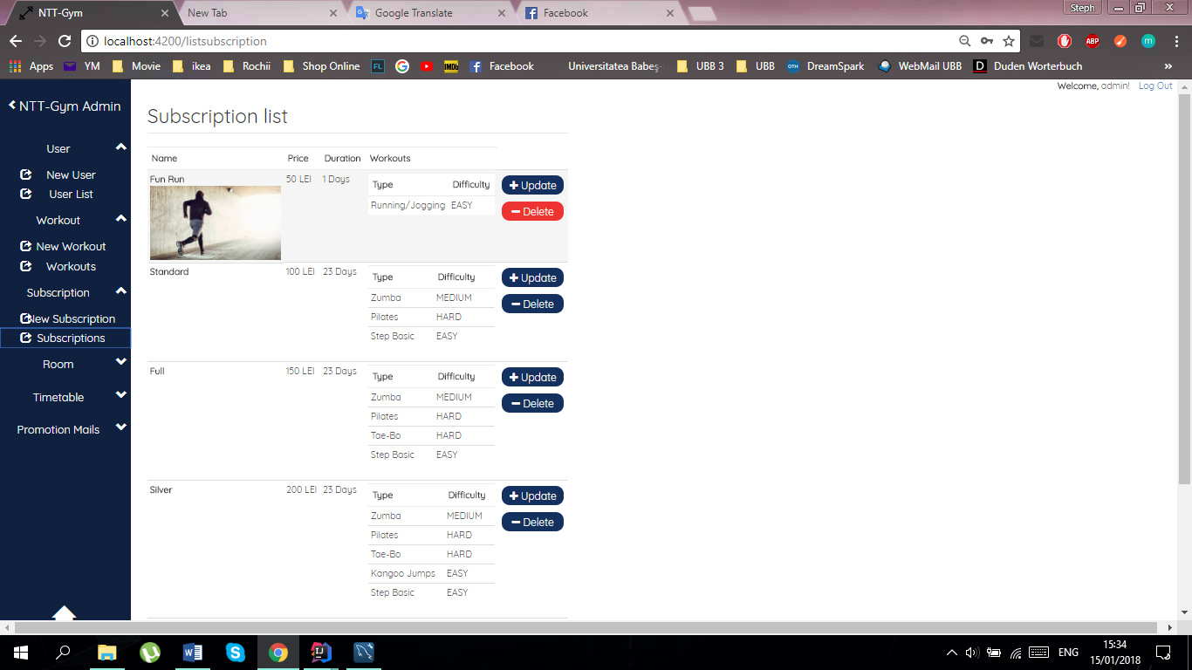

*Fig.* ***29.*** *Subscription List Page*

### *II.3.4 Room Management*

In this part you will be given information about the management of rooms of the gym application. The following functionalities will be included:

* Create New Room
* Room List
* Update Room
* Delete Room.

In order to access the room management page, the user has to be authenticated, and have administrative rights. You can access these functionalities by selecting the „Room” option from the menu, and then clicking on “Rooms” to get to the room page.

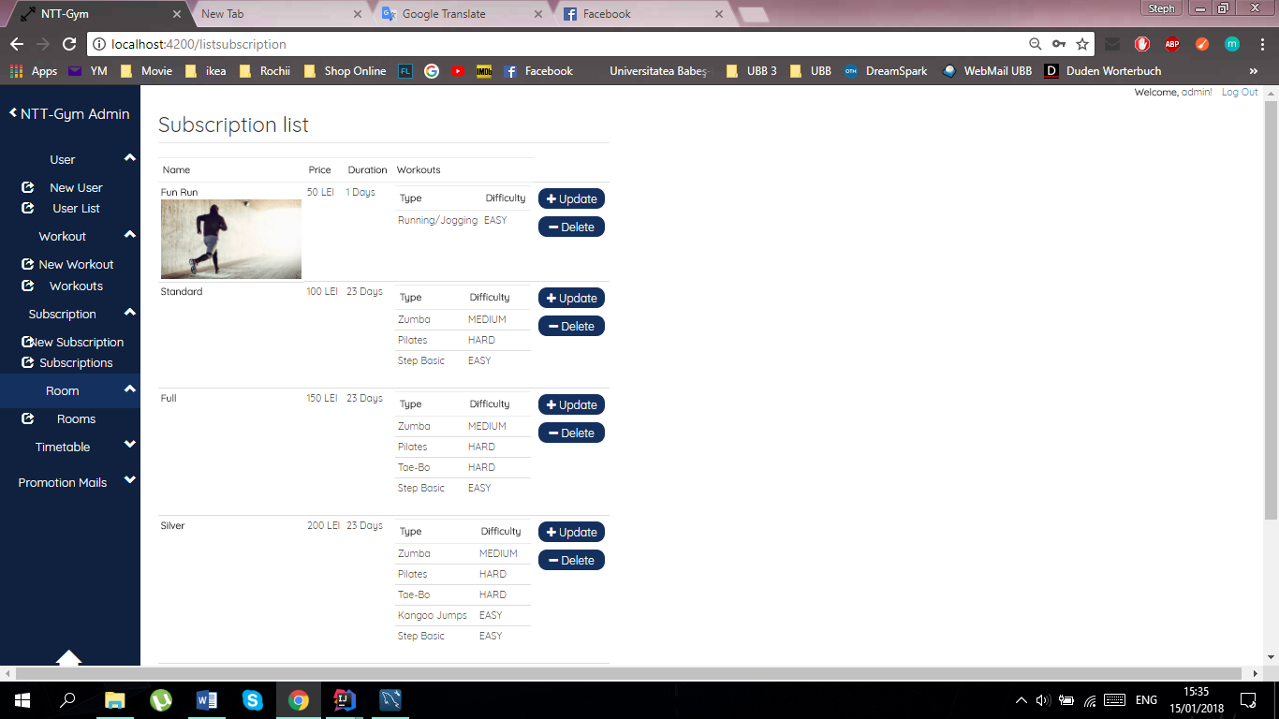

*Fig.* ***30.*** *Rooms Menu*

#### II.3.4.1. Room List

You have now arrived at the room page. Here you can manipulate the entries from the database in various ways. This is the list of all rooms.

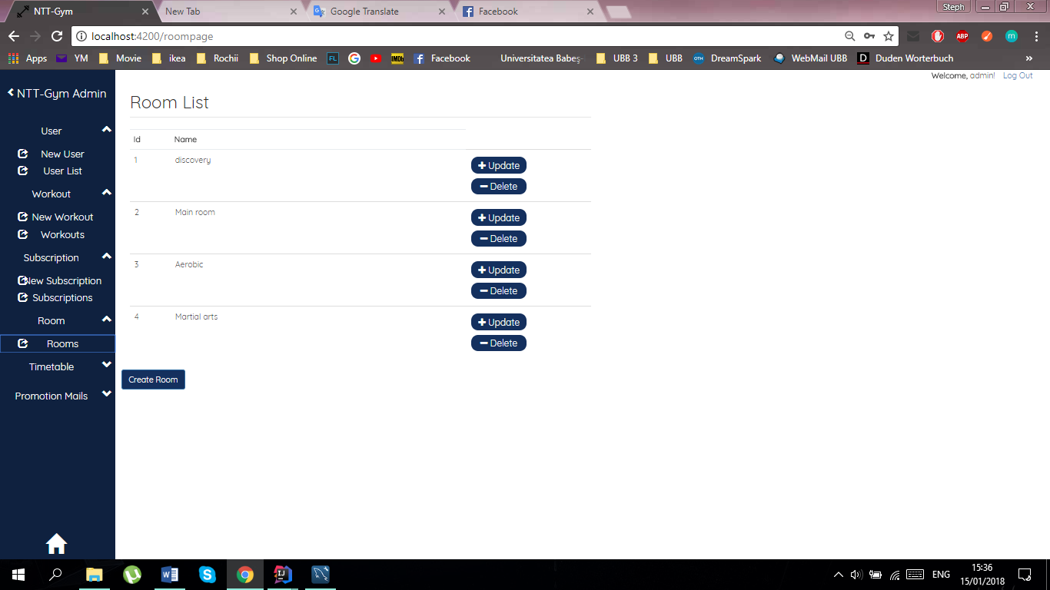

*Fig.* ***31.*** *Room List Page*

#### II.3.4.2. Room Creation

To create a new room, click on the Create button.



*Fig.* ***32.*** *Create room button*

A textbox will appear. Fill in with the room name and then click the “Submit” button. A new room with the given name will be created.

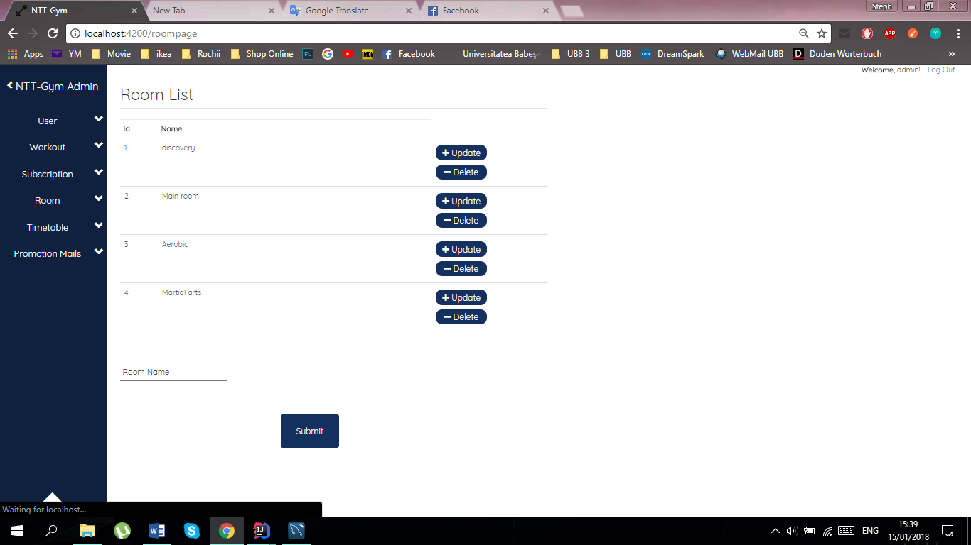

*Fig.* ***33.*** *Create room button*

#### II.3.4.3. Room Update

Click on the update button next to a room to quickly change its name.



*Fig.* ***34.*** *Update Button - Room List*

After clicking the update button, the text will become an editable textbox. Click on it and edit the text. After you’ve finished editing the text, click on finish.

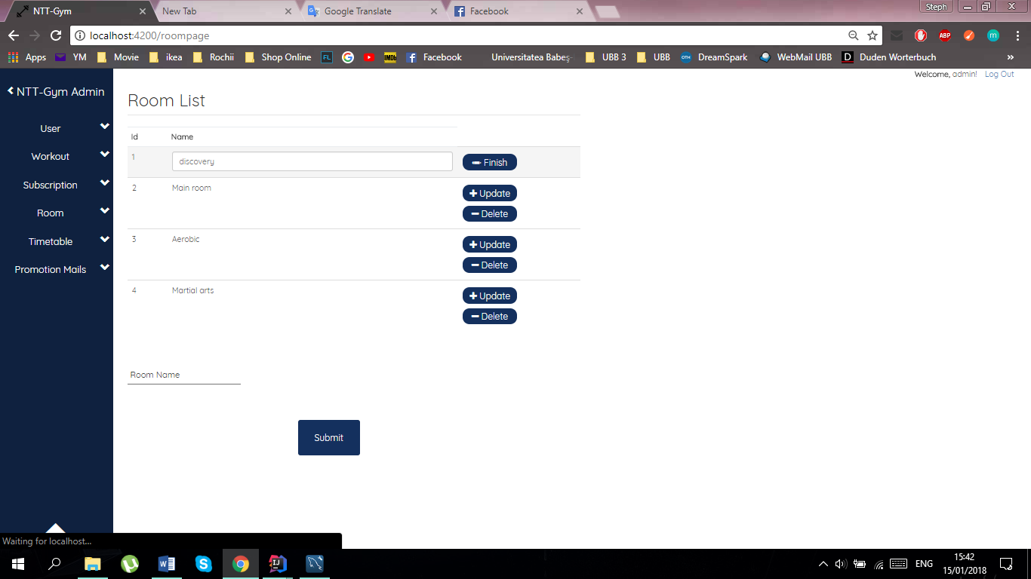

*Fig.* ***35.*** *Room List Update Name*

#### II.3.4.4. Room Deletion

To delete a room, just click on the delete button next to it.



*Fig.* ***36.*** *Delete Room*

### *II.3.5. Timetable Management\**

In this part you will be given information about the management of timetable entries of the gym application. The following functionalities will be included:

* Create New Timetable Entry
* Timetable Entry List
* Update Timetable Entry
* Delete Timetable Entry.

In order to access the timetable management pages, the user has to be authenticated, and have administrative rights. You can access these functionalities by selecting the „Timetable” option from the menu. The timetable component contains two options: one to create a new timetable entry and one to administrate all the existing timetable entries.

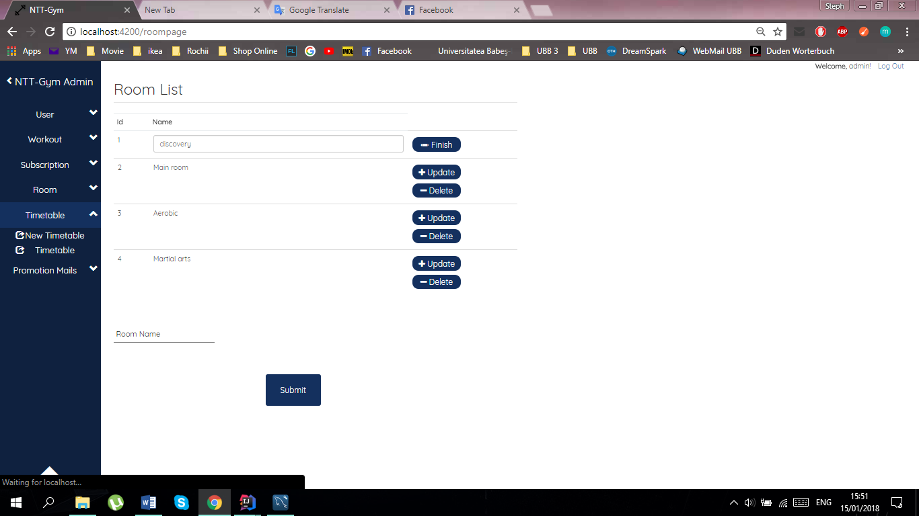

*Fig.* ***37.*** *Timetable options*

#### II.3.5.1. Timetable Entry Creation

In order to create a new timetable entry, you will have press on the first option “New Timetable” and to fill the given brackets: the day, the starting hour, the duration, the room, the workout type and the trainer.

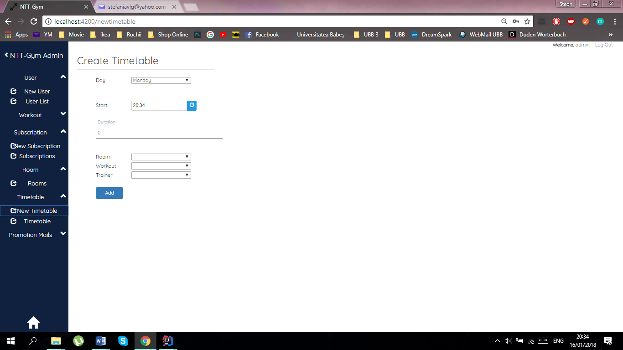

*Fig.* ***38.*** *Create Timetable Page*

After completing all the necessary information, you will have to press on the “Add” button and your timetable entry will be successfully created. A success message will be displayed, if the new entry has been successfully saved in the database.

#### II.3.5.2. Timetable Entry List

In order to access the list of all your timetables entries, you have to choose the second option “Timetable” from the “Timetable” dropdown.

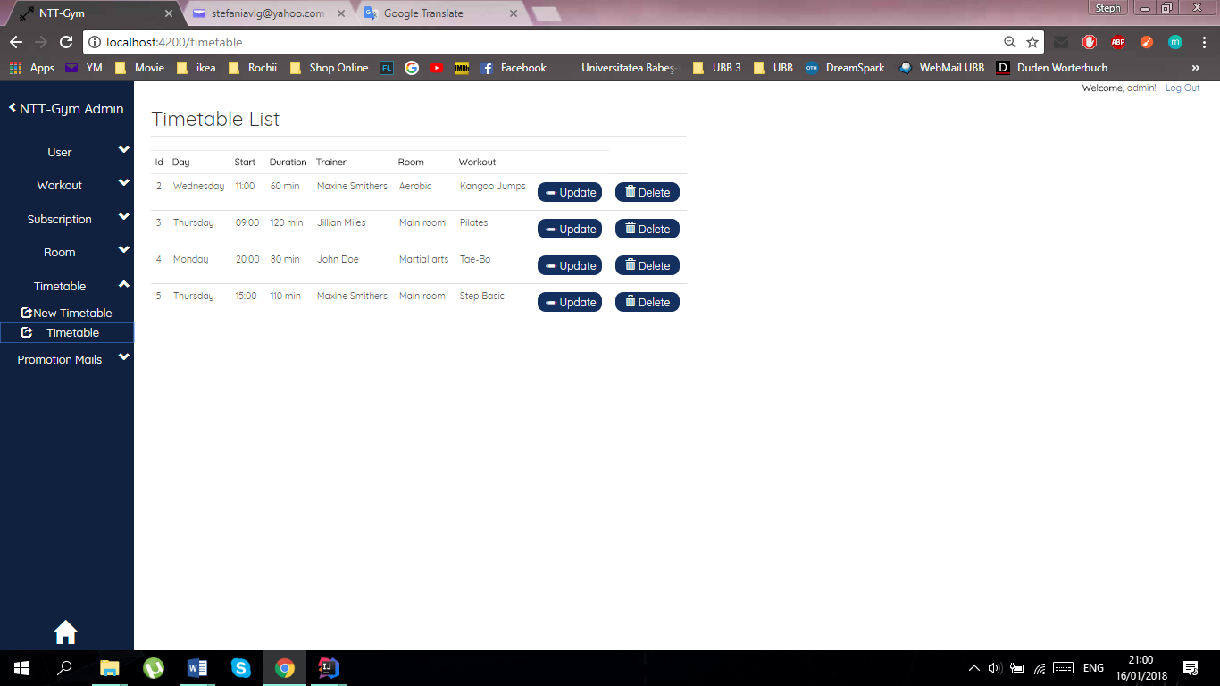

*Fig.* ***39.*** *Timetable List Page*

On this page you have the option to alter a timetable entry by pressing the “Update” button or to erase a one by pressing the “Delete” button.

#### II.3.5.3. Timetable Entry Update

By pressing the “Update” button on a timetable entry in the timetable entries list, a new page will be opened where you can see and alter all the details about that specific entry.

Here you have the possibility to alter the day, the starting hour, the duration, the room and the workout type of that timetable entry.

In order to save all the modifications you will also have to press the Update button. If the update has succeeded in the database, a success message will be displayed.

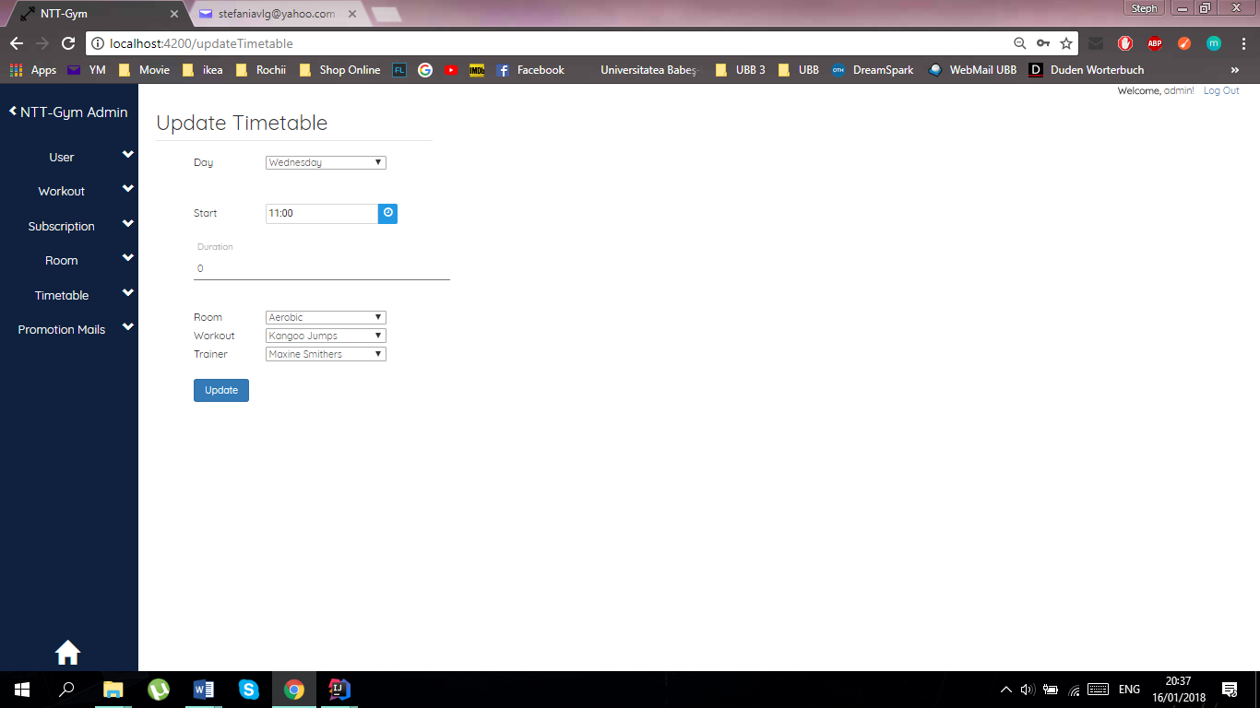

*Fig.* ***40.*** *Update**Timetable Page*

#### II.3.5.4. Timetable Entry Deletion

When a particular timetable needs to be deleted, this can simply be done by using the “Delete” button, which is located on the right of the (Timetable List) page, next to the “Update” button. One click on the button will delete the timetable that is no longer needed and a confirmation message will be shown.



*Fig.* ***41.*** *Timetable List Page*

### *II.3.6. Promotion Mails Management*

In this part you will be given information about the management of promotion mails entries of the gym application. The following functionalities will be included:

* + Send Mail.

In order to access the promotion mails management pages, the user has to be authenticated, and have administrative rights. You can access these functionalities by selecting the „Promotion Mails” option from the menu.

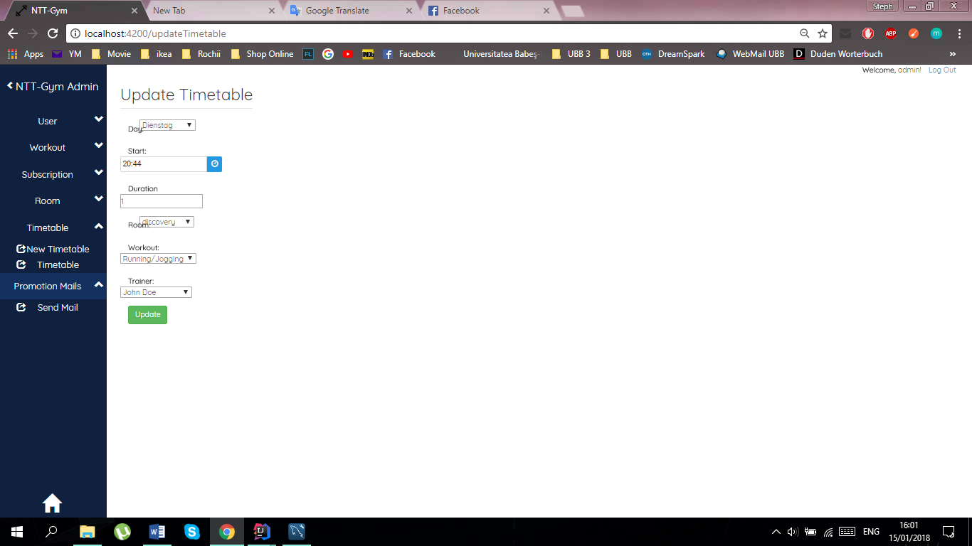

*Fig.* ***42.*** *Promotion Mails Menu*

#### II.3.6.1. Sending E-mails

In order to access the page from which you can send e-mails, you have to choose the option “Send Mail” from the “Promotion Mails” dropdown.

You will have to write a subject to your mail and the content. After that you can choose to which group of people to address the email. The groups are made based on the subscription.

Once you have written your e-mail just click the button “Send”.

A message will appear if the e-mail was sent successfully.

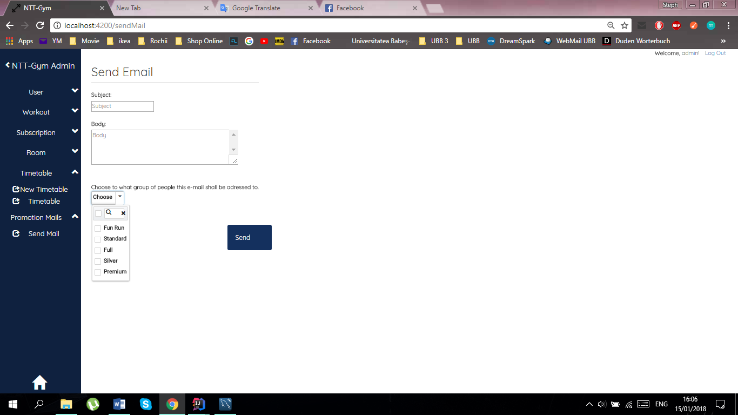

*Fig.* ***43.*** *Send Mail*

## **II.4. Client Overview**

In this part you will be given information about the client overview of the gym application. The following pages will be included:

* Home
* Trainers
* Subscription
* Schedule
* Contact.

In order to access these pages, the user has to be authenticated, and have client rights. You can access these pages by selecting one of the options from the menu.

### *II.4.1. Home*

Once you have logged yourself in, you will be directed to the following page.



*Fig.* ***44.*** *Home page for Client*

You can choose one of the options shown in the picture.

### *II.4.2. Trainers*

In the “Trainer Overview” you can see the basic information about each trainer that our gym has. If you want to rate a specific trainer, you can use the 5-star rating (1 – poor, 2 – below average, 3 – average, 4 – above average, 5 – excellent). This can only be done if you are logged-in!

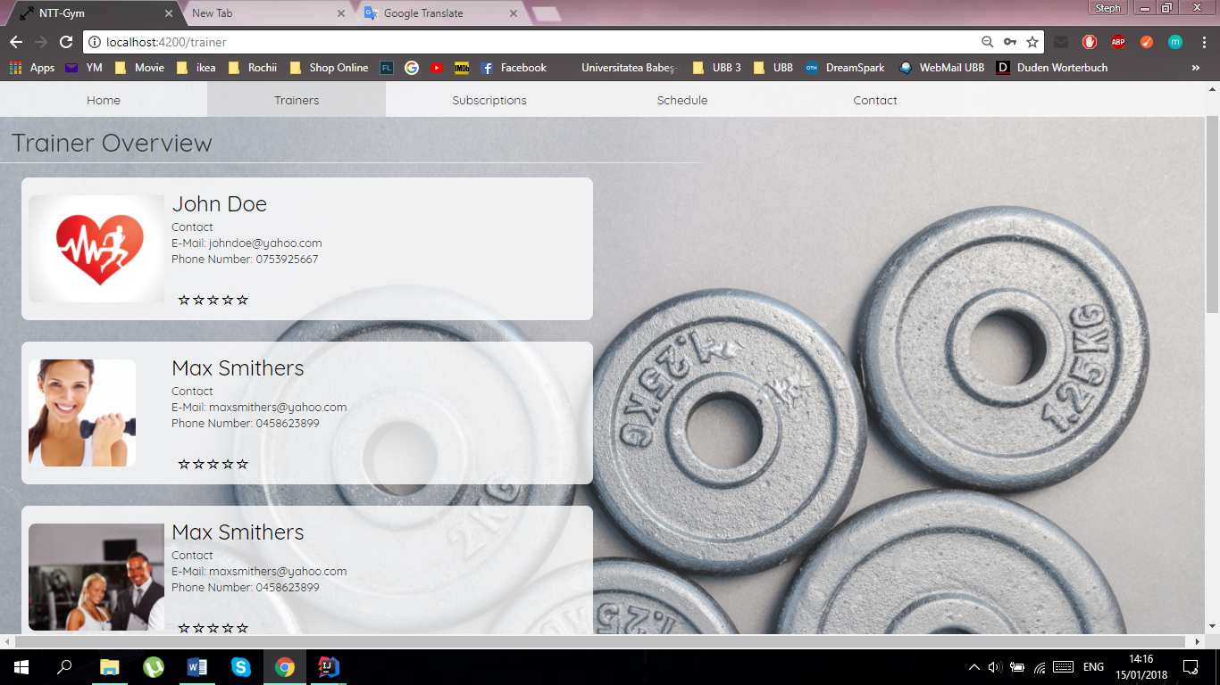

*Fig.* ***45.*** *Trainers for Client*

### *II.4.3. Subscription*

If you want to see the available subscriptions just click on the “Subscriptions” button. This will lead you to the page below. Here you can see the name of the subscriptions, the price and a description. If you want to express your like or dislike about one of the subscriptions just use the 5-star rating to rate it. (This can only be done if you are logged-in!)

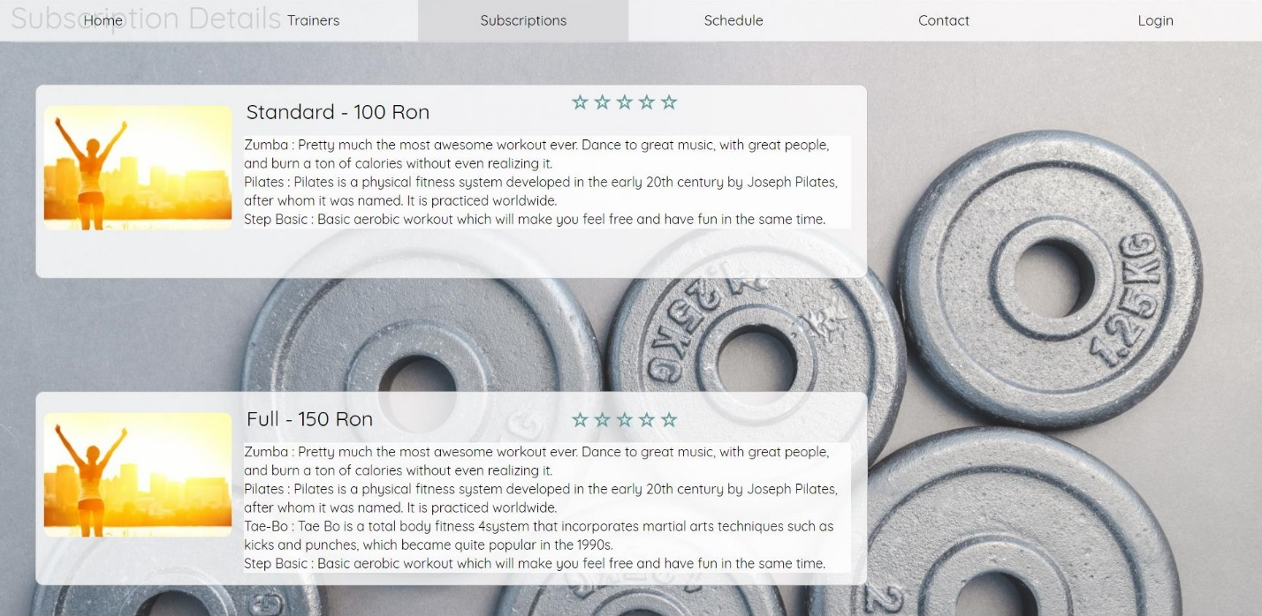

*Fig.* ***46.*** *Subscriptions*

### *II.4.4. Schedule*

Once you click the “Schedule” button you can see the schedule with workouts that are available at the moment.

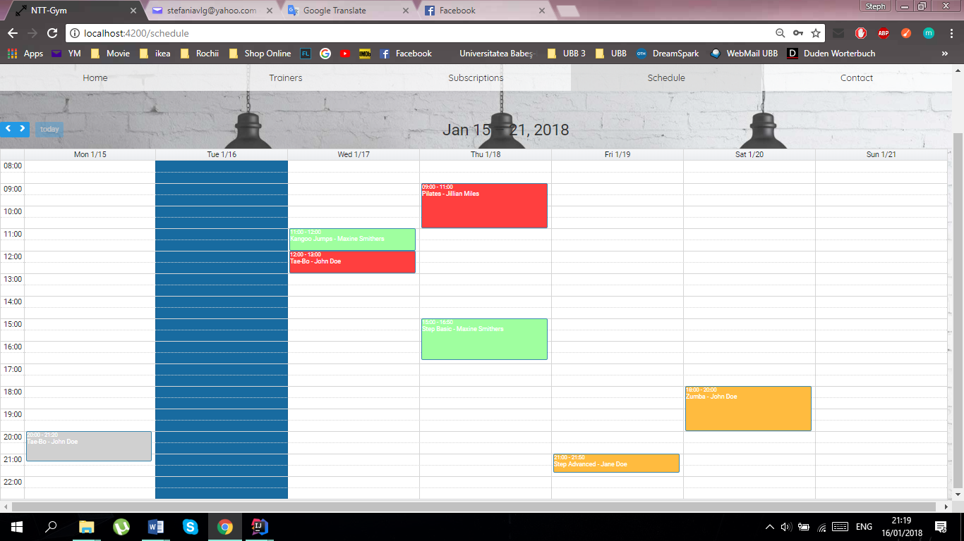

*Fig.* ***47.*** *Schedule*

Color explanations: light grey = classes that are already in the past, blue = today, green = classes of easy intensity, red = classes of high intensity, orange = classes of medium intensity.

If you are logged-in you can register to one of the available classes. However if you are already registered to a class, then a star will be shown on the note.

You can also look for future classes that will be held. With the help of the arrows on the left, you will be able to look through every week and see all the future classes.

You cannot register to a class which has already begun or ended, and if the subscription expired.

### *II.4.5. Contact*

If you want to know the basic information about the GymApp, just click on the “Contact” button. As seen below, there is a map with the location of the Gym and also the phone number, address and the working hours.

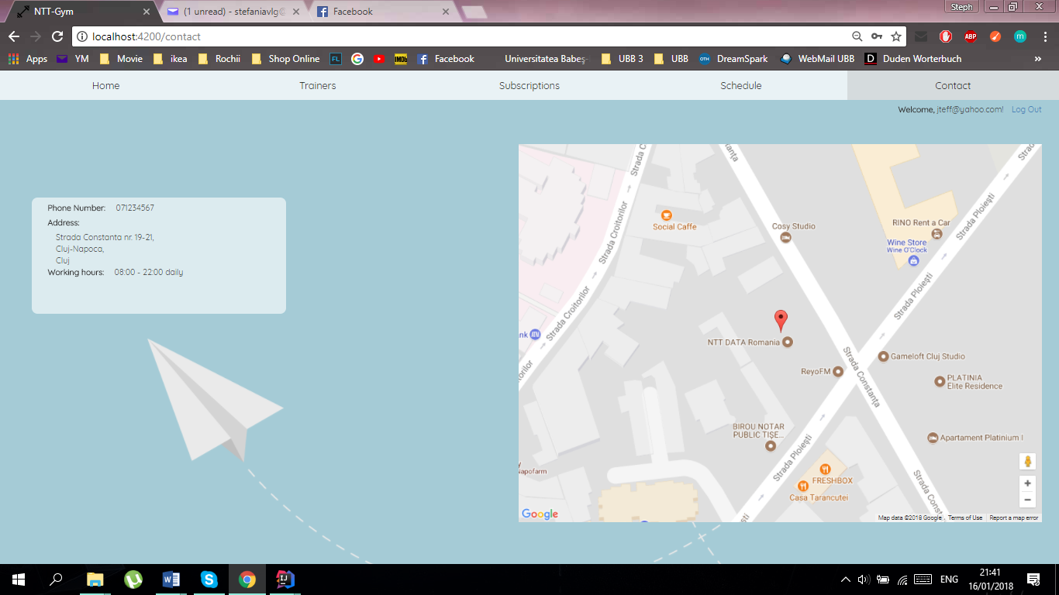

*Fig.* ***48.*** *Contact*